Compte rendu (TP 7 ) Grpe B
Génie.Info 2
ADOGNIBO Hortice

TP7
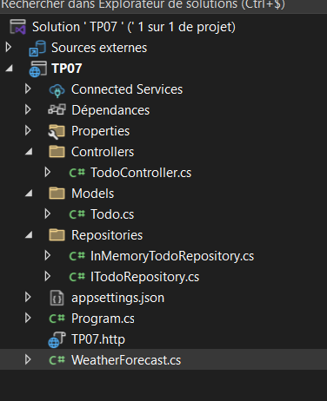
Models
Todo.cs:
using System.ComponentModel.DataAnnotations;
namespace TP07.Models
{
public class Todo
{
public int Id { get; set; }
[Required(ErrorMessage = "Le titre est obligatoire.")]
[MaxLength(100, ErrorMessage = "Le titre ne doit pas dépasser 100 caractères.")]
public string Title { get; set; }
public bool IsDone { get; set; }
}
}
Repositories:
ITodoRepository.cs:
using System.Collections.Generic;
using TP07.Models;

namespace TP07.Repositories
{
public interface ITodoRepository
{
IEnumerable<Todo> GetAll();!;
Todo? GetById(int id);
Todo Add(Todo todo);
bool Update(int id, Todo todo);
bool Delete(int id);
}
}

InMemoryTodoRepository.cs:
using System.Collections.Generic;
using System.Linq;
using System.Xml.Linq;
using TP07.Models;
using TP07.Repositories;

namespace TP07.Repositories
{
public class InMemoryTodoRepository : ITodoRepository
{
private static List<Todo> _todos = new List<Todo>();

private static int _nextId = 1;

public InMemoryTodoRepository()
{
if (_todos.Count == 0)
{
_todos.Add(new Todo { Id = _nextId++, Title = "Apprendre .NET", IsDone = false });
_todos.Add(new Todo { Id = _nextId++, Title = "Faire le TP de GI", IsDone = true });
_todos.Add(new Todo { Id = _nextId++, Title = "Réviser pour l'examen", IsDone = false });
}
}
public IEnumerable<Todo> GetAll()
{
return _todos;
}
public Todo? GetById(int id)
{
return _todos.FirstOrDefault(t => t.Id == id);
}

public Todo Add(Todo todo)
{
todo.Id = _nextId++;
_todos.Add(todo);
return todo;
}

public bool Update(int id, Todo updatedTodo)
{
var existingTodo = GetById(id);
if (existingTodo == null)
return false;

existingTodo.Title = updatedTodo.Title;
existingTodo.IsDone = updatedTodo.IsDone;

return true;
}

public bool Delete(int id)
{
var todo = GetById(id);
if (todo == null)
return false;

return _todos.Remove(todo);
}
}
}
Program.cs:
using TP07.Repositories;

var builder = WebApplication.CreateBuilder(args);

builder.Services.AddSingleton<ITodoRepository, InMemoryTodoRepository>();

builder.Services.AddControllers();

// Swagger
builder.Services.AddEndpointsApiExplorer();
builder.Services.AddSwaggerGen();

var app = builder.Build();

// Dev tools
if (app.Environment.IsDevelopment())
{
app.UseSwagger();
app.UseSwaggerUI();
}

app.UseHttpsRedirection();

app.UseAuthorization();

app.MapControllers();

app.Run();

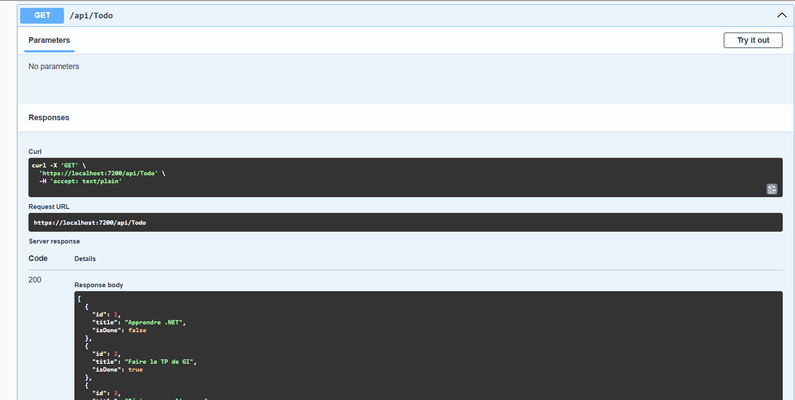
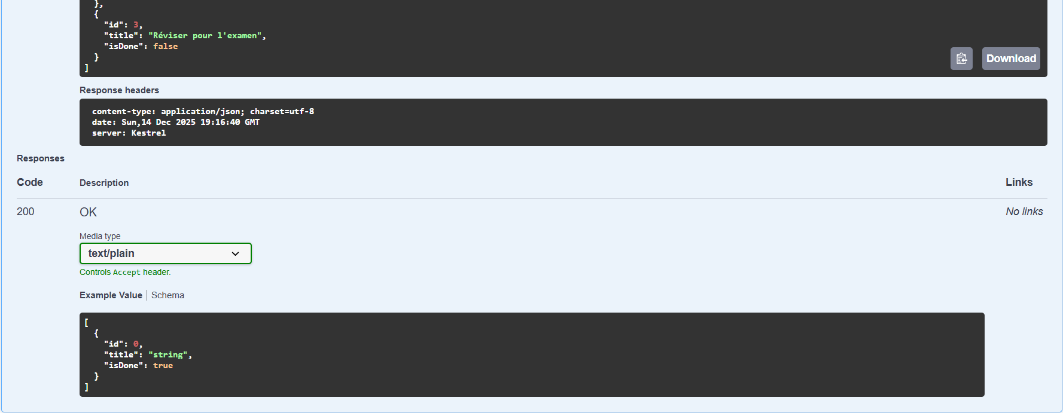
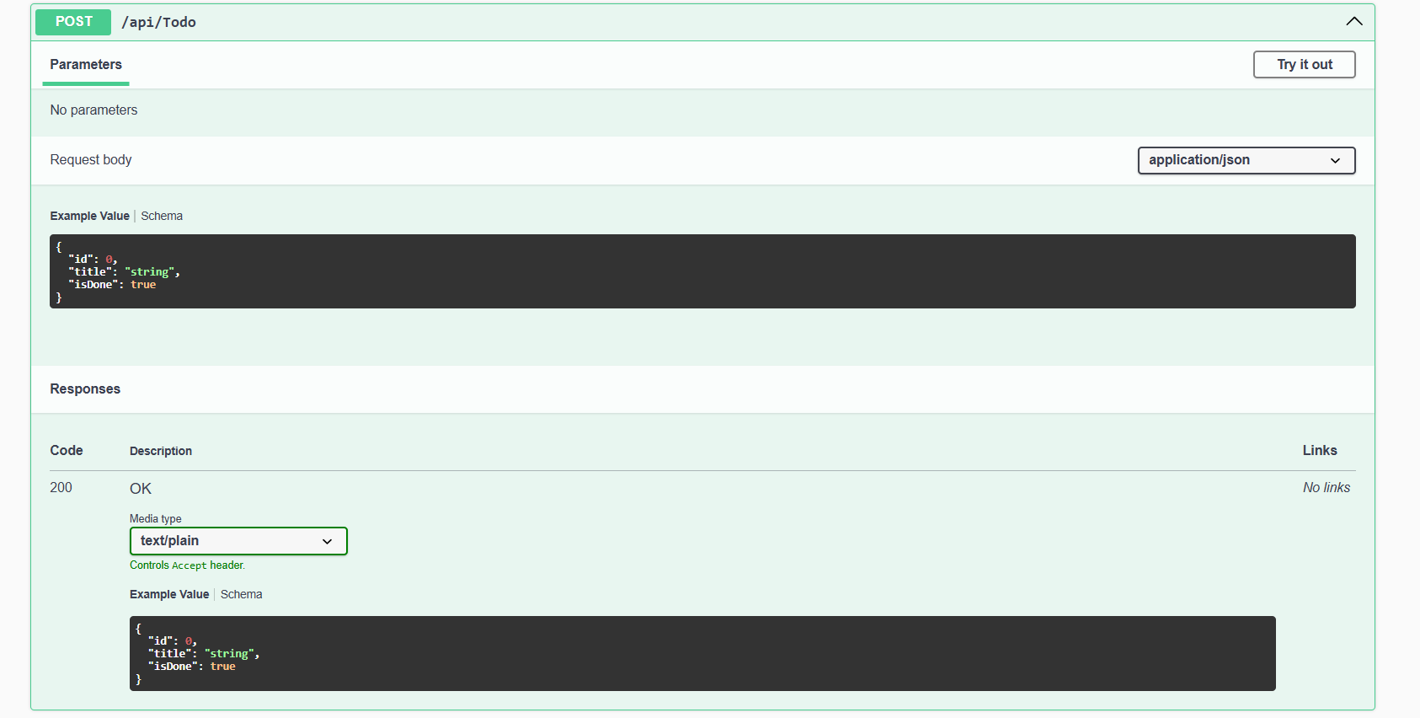
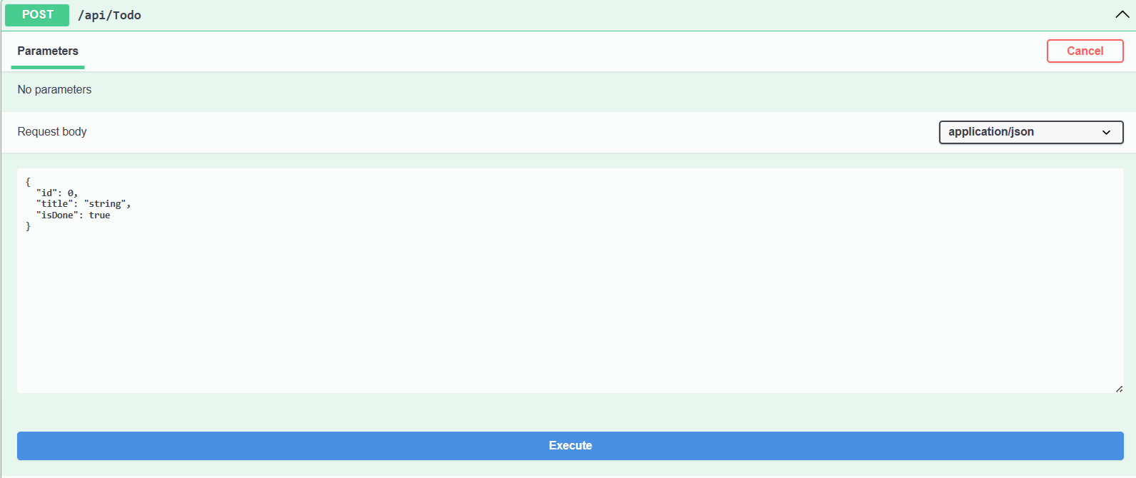
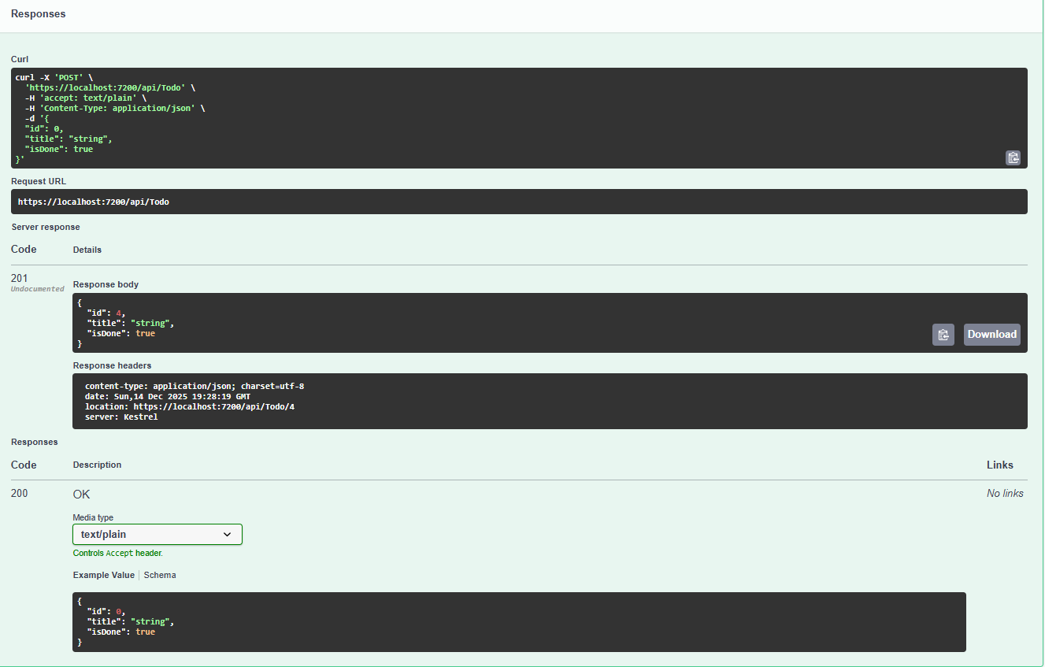
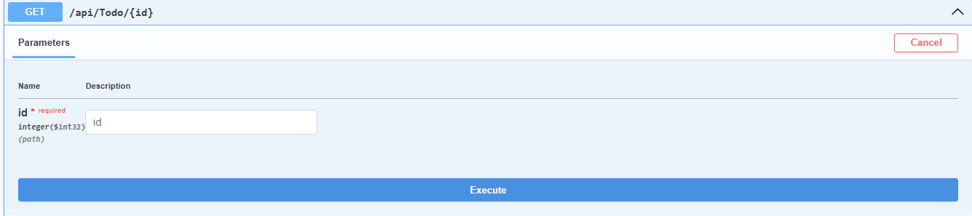
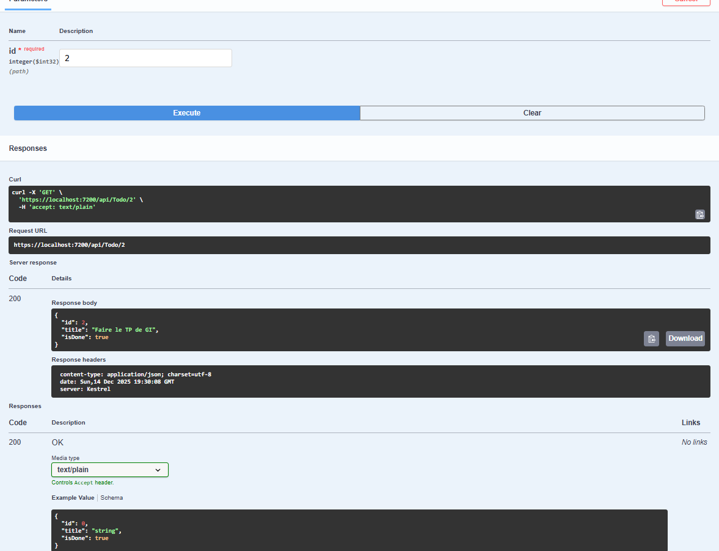
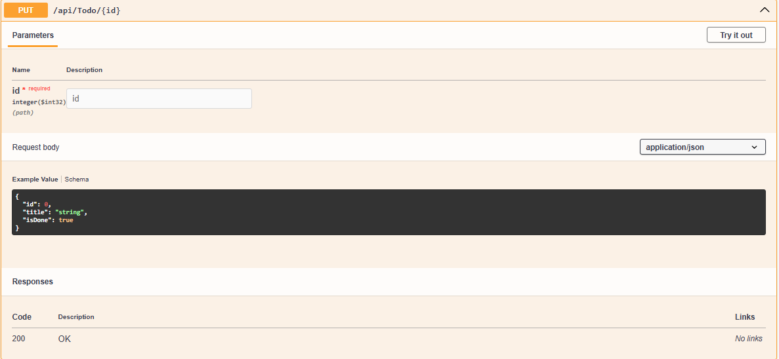
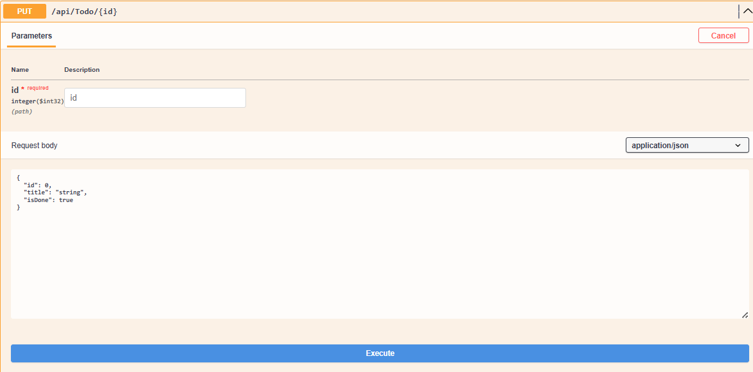
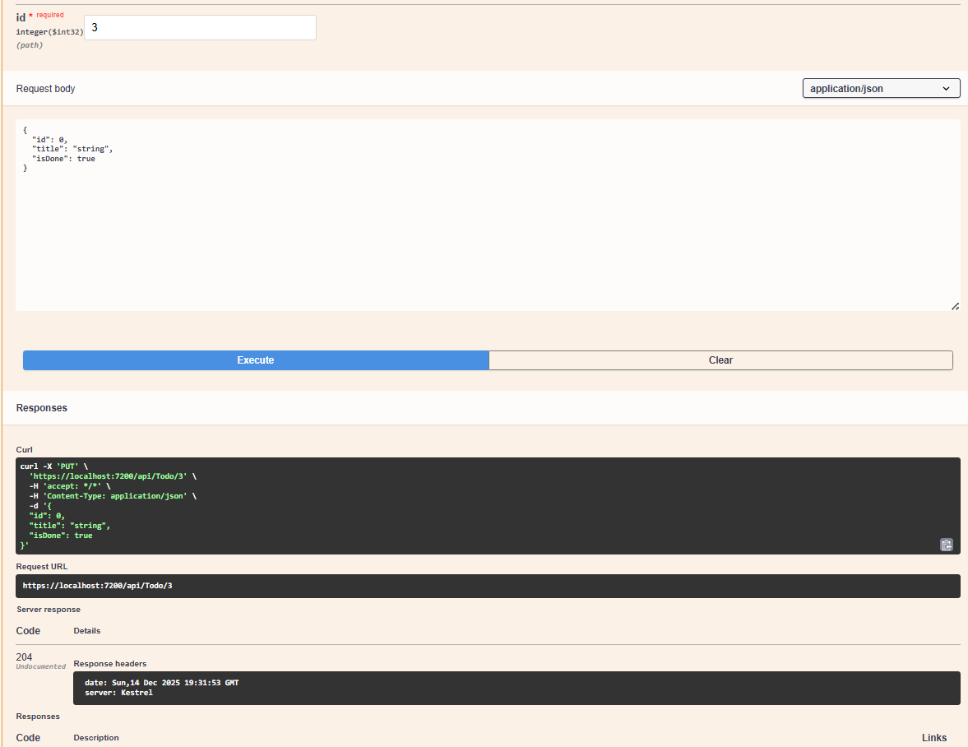
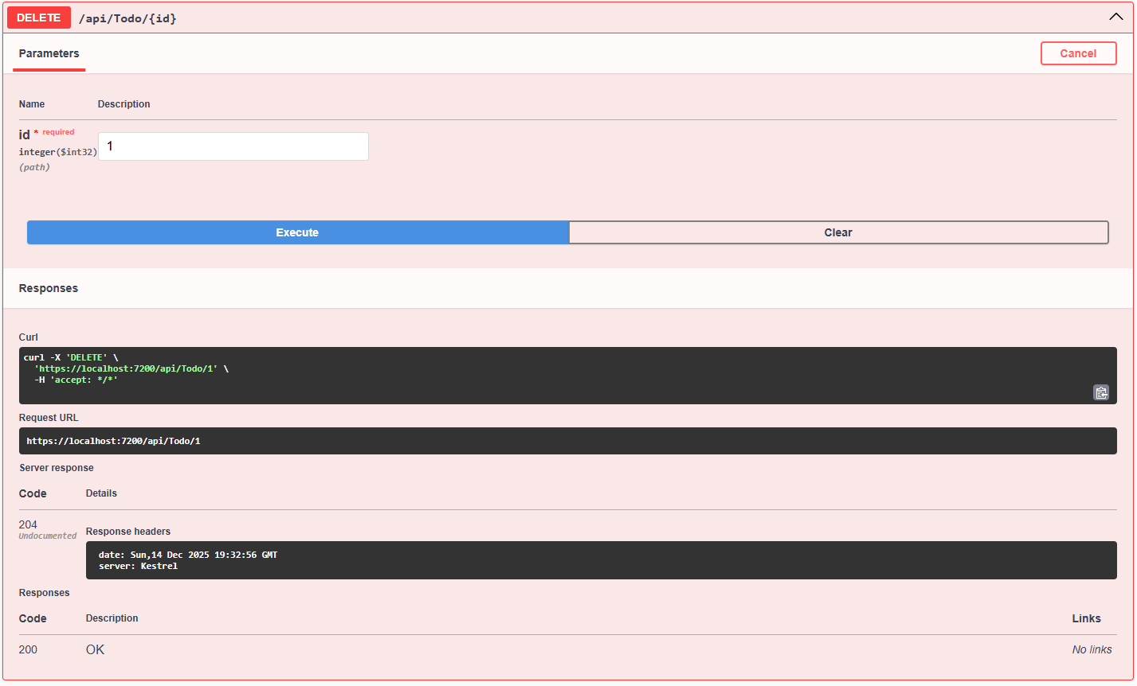
Controllers:
TodoController.cs:
using Microsoft.AspNetCore.Mvc;
using System.Collections.Generic;
using TP07.Models;
using TP07.Repositories;

namespace TP07.Controllers
{
[ApiController]
[Route("api/[controller]")]
public class TodoController : ControllerBase
{
private readonly ITodoRepository _todoRepository;
public TodoController(ITodoRepository todoRepository)
{
_todoRepository = todoRepository;
}
[HttpGet]
public IEnumerable<Todo> GetAll()
{
return _todoRepository.GetAll();
}
[HttpGet("{id}")]
public ActionResult<Todo> GetById([FromRoute] int id)
{
var todo = _todoRepository.GetById(id);
if (todo == null)
{
return NotFound();
}
return Ok(todo);
}
[HttpPost]
public ActionResult<Todo> Create([FromBody] Todo todo)
{
if (todo == null || string.IsNullOrWhiteSpace(todo.Title))
{
return BadRequest("Le Todo est invalide.");
}
_todoRepository.Add(todo);

return CreatedAtAction(nameof(GetById), new { id = todo.Id }, todo);
}
[HttpPut("{id}")]
public ActionResult Update([FromRoute] int id, [FromBody] Todo todo)
{
if (todo == null || string.IsNullOrWhiteSpace(todo.Title))
{
return BadRequest("Le Todo est invalide.");
}

var existingTodo = _todoRepository.GetById(id);
if (existingTodo == null)
{
return NotFound();
}

_todoRepository.Update(id, todo);

return NoContent();
}
[HttpDelete("{id}")]
public ActionResult Delete([FromRoute] int id)
{
var existingTodo = _todoRepository.GetById(id);
if (existingTodo == null)
{
return NotFound();
}

_todoRepository.Delete(id);

return NoContent();
}

}
}

